Dear Paul,

It seems that the slider images are good. They will look even better when you remove the white box in the middle. On the opening screen it should not be there. In my opinion it will have more of an impact without the box. Also there is no good text to put in this box.

You can make the slider a bit less tall (it is almost 3’’ and can be 2 ¼’), the yellow-orange stripe can also be shorter (instead of ¾ ‘ to ½’)

My screen is 1600x 900 what I see is as shown on the next page:



This is not well organized on my screen. Also the selector is not visible, without sliding down.

What I should see is:

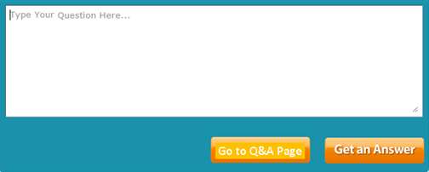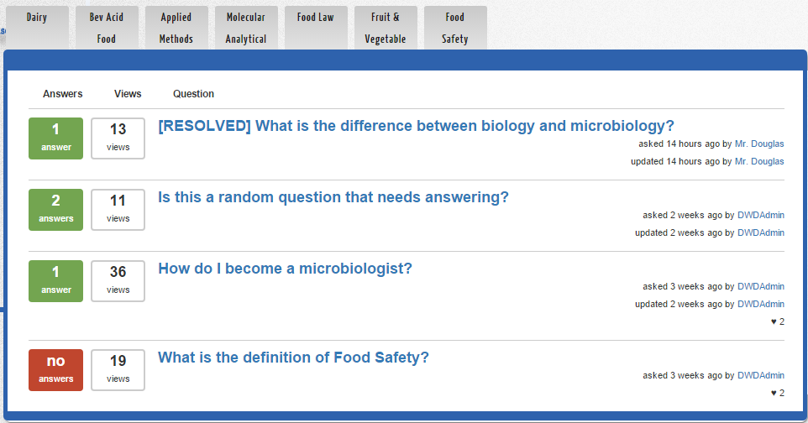

Please note that no stats should be on the selector in the front page. There should be a button to the “Q&A page” and to the “get an answer” page. The original specs for details on what each of these pages contain.

I like to see all of it in a page without a need to move the cursor or the slide down.

The same is true for the “create an account” page.